Fast Fourier Transform Algorithm and Technical Analysis

I have studied MSFT(Microsoft) daily historical prices from Yahoo finance between 2015-08-21 and 2017-08-21. One of the limitations of using the FFT function is that the number of data points operated on must be a number that is a power of two. For example, I have chosen 512 data points that is $2^{9}$.

Let’s assume sampling frequency is 100, calculations of FFT complex and FFT magnitude values can be found in python file.

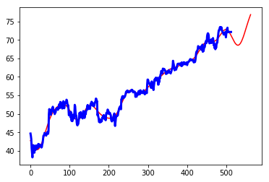

frequency

This is the representation of the time series data in frequency of the sinusoidal curve depicting the transformed data.